Instructions for the placement of cameras of phototraping and calculation of density of wild boar
This section presents basic instructions to estimate the density of wild boar through the use of camera traps (CTs). Since different methods are available, we will focus on a practical one that is capable of generating reliable data in a wide range of situations (and species) throughout Europe. The random encounter (REM) model does not require individual recognition. However, it is necessary to collect certain information to determine the speed of movement (average daily movement range) of the wild boar. Therefore, it is necessary to place marks or stakes at a distance from the CTs that serves as a guide to subsequently mark the path followed by each animal, as indicated below.

• The work should be developed during autumn/early winter, with the CTs placed a minimum of 60 days.
• They will be placed (registering the geographical coordinates) following a regular uniform distribution as a grid with a minimum of 45 camera placements. The separation between CTs will be approx. 1.5 km. The exact location can be within a diameter of less than 100m around the points of the grid. If the number of CTs available is not enough to sample the 45 placements at the same time, the CTs should be moved during the experiment to cover the minimum of 45 locations.
• The grid must cover at least one patch beaten during the hunting season, if possible more; or several grids for several patches.
• Place stakes in 2.5m intervals (Figure). Connecting the stakes with signaling tape helps to better visualize distances (Fig C). Finally, ensure that a photograph is taken from the CT where these stakes are evident. Put natural marks (stones, branches…) before remove the stakes for later identification of the path of the animals photographed (Figure D).
• The CT will be placed on poles or vegetation 40cm above the ground.
• The CT is configured with operation of 24 hours per day and to take up to three consecutive images (the maximum number possible), with the minimum waiting time (0 sec. if possible) between activations. Use medium sensitivity.
• The flash intensity should be set at medium (if possible) to avoid “overexposed photos”.
• Check that the date and time are correctly set, and that they are printed automatically on each image.
• The CT should be reviewed at least in the half of the study period (ideally once a month) to check its functioning and placement. Normally it will not be necessary to change the batteries and the memory cards, since the CTs are placed at random points and high wildlife activity is not expected.
• Choose a field of vision of the CT that is cleared of vegetation (it is not necessary to be totally clean, but that allows the detection of any wild boar that passes within the first 5 m), being better a north orientation.
• A form must be filled in, collecting the information of each CT during its placement (see below). All the information that is subsequently extracted must keep the traceability of the CT (mark the source camera of each memory card extracted, and keep this nomenclature in the folders that are created on the computer to archive the images).

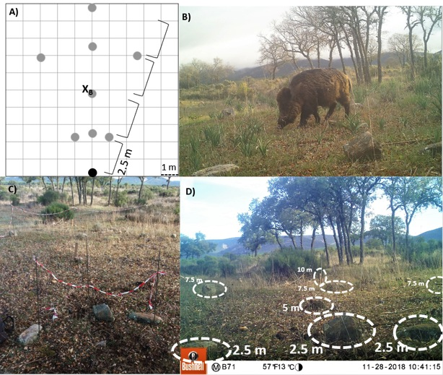
Figure. A) Scheme of the stick-structure (grey dots) used to reference the animal captured by the camera-trap (black dot). X_{B} indicates the position of the wild boar captured in the image B. B) Wild boar photo-captured. C) Photo of the structure installed in one photo-trapping sampling point. The camera should be oriented so that the well-centred stakes are displayed. D) Natural marks (stones) used as references after removing stakes.

Required material

• CT adequately configured (see above), with proven batteries (alkaline) and compatible memory card. Check that the cards save the photos well, since sometimes they are not compatible with the camera model.
• Memory card of 8 GB minimum size, recommended 16 GB if the camera supports it.
• 50 cm stakes (or poles) and hammer to place them. 8 of them are required for the initial photograph of each study point. 2 of them will stay (5 and 10 m)..
• Signalling tape.
• GPS for recording geographical coordinates.
• Single-use camps are very practical for fixing the cameras.
• Hoe for vegetation cleaning, only the strictly necessary within the first 5 meters.

Nº of the study point | Nº CT and memory card | Coordinate X | Coordinate Y | Date setting-up CT in the field | Time setting-up CT in the field | Picture of vision field with marks taken? (Y/N) | Date CT removal | Time CT removal | Observations: any eventuality, indicate if revision is made, the date of this, aspects of functioning of the CT, if it dropped down, if still correctly attached, any failure, change of memory or batteries, etc.
1 | /
2 | /
3 | /
4 | /
5 | /
6 | /
7 | /
8 | /
9 | /
10 | /
11 | /
12 | /
13 | /
14 | /
15 | /
16 | /
17 | /
18 | /
19 | /
20 | /

Nº of the study point | Nº CT and memory card | Coordinate X | Coordinate Y | Date setting-up CT in the field | Time setting-up CT in the field | Picture of vision field with marks taken? (Y/N) | Date CT removal | Time CT removal | Observations: any eventuality, indicate if revision is made, the date of this, aspects of functioning of the CT, if it dropped down, if still correctly attached, any failure, change of memory or batteries, etc.
21 | /
22 | /
23 | /
24 | /
25 | /
26 | /
27 | /
28 | /
29 | /
30 | /
31 | /
32 | /
33 | /
34 | /
35 | /
36 | /
37 | /
38 | /
39 | /
40 | /

Nº of the study point | Nº CT and memory card | Coordinate X | Coordinate Y | Date setting-up CT in the field | Time setting-up CT in the field | Picture of vision field with marks taken? (Y/N) | Date CT retrieval | Time CT retrieval | Observations: any eventuality, indicate if revision is made, the date of this, aspects of functioning of the CT, if it dropped down, if still correctly attached, any failure, change of memory or batteries, etc.
 | /
 | /
 | /
 | /
 | /
 | /
 | /
 | /
 | /
 | /
 | /
 | /
 | /
 | /
 | /
 | /
 | /
 | /
 | /
 | /
Use as many forms as necessary

